September 2015 Newsletter

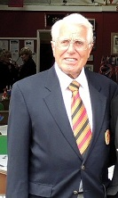

Commodores Report
First, I must offer my and, I am sure, the club’s heartfelt condolences to Wendy and John following the loss of Wendy’s son Simon. Simon lost his brave fight for life in the early hours of the 12th of this month.
We now have a telephone landline and broadband (phone 01932 267390). This means that I can now complete the Club brochure and business card including the new phone number. The intention is to set up caller divert to a member’s home phone number should the phone not be answered at the club. Wendy has volunteered for this but meanwhile I will use my mobile number.
As reported last month, the ATYC Rally was cancelled as the WMC was the only club to register a full fleet for the event. The event was replaced by a barbecue at the TMYC and we were given a priority invitation (see separate report and photos).
On the 6th was the Dunkirk Veterans event (not just DV though – see the report). A great success and it made me proud to be of the WMC. There were many thanks from the guests and VIPS. I hope the members who took part managed to enjoy the event. I also thank those members not involved in helping for staying away – your contribution in this way was very important. Earlier in the year there was a major health and safety issue with the pontoon ramps, with last year the very hazardous disembarkation of the vets – the ramps were too steep and pitched up off the bank. However, thanks to Jim H and his hard working crew the problem was solved in time by reversing the ramps.
We are now certified - perhaps we should be!! No, this is certification we have been awarded by the local authority for kitchen and food preparation. I must thank Brian C for liaising with the LA for this, and Lesley for making sure that all suspect food had been removed. In fact, Brian reported that the inspector thought the kitchen was so clean and tidy it appears not to have been used!
I still have no solution to the parking problem. I am awaiting a response from the island syndicate that now own the far car park.
I didn’t get any response to my desperate request in the last newsletter for help on the committee. Is there no one out there willing to put their name forward? If you are thinking of it, but are uncertain as to the commitment, why not talk it over with me: your club needs you!
Jim Pothecary.

The Alternative ATYC Rally
or
The WMC at The TMYC
The ATYC Rally this year was to have been held at Kingston on the August bank holiday for various reasons. However, we were informed that the WMC was the only club to register a significant number of boats for the rally, which resulted in its cancellation.
As a replacement for the cancelled rally, the Thames Motor Yacht Club, Hampton Court, arranged a barbecue for Sunday 30th August and as a consequence, Rob (Rear Commodore Non-Tidal) had received a preferential invitation for the WMC to go to the barbecue. This led Rob to arrange an alternative bank holiday cruise for those who booked for the ATYC Rally: all meeting at the Hampton Court Palace mooring on Saturday 30th for evening dinner in the local chippy, then on to the TMYC for a BBQ on Sunday.
I had set off early on Friday to cruise to the club and stayed there for the night. Fortunately, Gordon and Jess (Gorjess), Chris and Su (Alouette) and Russell, Theresa and Mark (Lady Redmac) had gone down early on Friday to successfully secure moorings for the rest at Hampton Court. On the Saturday we all assembled; eventually each finding a bankside mooring after a bit of shuffling around. The boats attending were KalipsΩ, Alouette, Gorjess, Weather or Knot, Bibi, Lady Redmac, Harvey’s Joy, Myownie and Miss Bea.
An evening dinner was booked for 20 at the Carp and Trout fish and chip café in Molesey. As the chippy is quite small, we took over the whole of the seating in the café; in fact, in the end we sat 22. And what a great evening it was: plenty of banter (& batter), great food and great company – and the stealing of food by those waiting to be served. Apart from the crews we were joined by Frank and Heather and Roger and Jean. All agreed that Rob had done a smashing job to plan and book the meal. The merriment continued on the way back to the boats in the dark.
Sunday morning dawned overcast but warm and humid; rain had been forecast for later in the day (but, fortunately never arrived). At around midday some walked to the TMYC while others climbed aboard Harvey’s Joy to make their way there.
We arrived to find TMYC members bustling around to get everything ready. Even their Commodore, Mandy Want was preparing food. The bar was open, which suited the WMC mob very well and while waiting for the food there was plenty of opportunity for many of the Mariners to remake acquaintance with old friends. We found that the only clubs invited were the ATYC and the Weybridge Mariners and Windsor Boat Clubs.
The food was delicious: salad, burger, cheese and roll, sausage, kebab and prawns on a stick! This was followed with sumptuous gateaux and cheesecake. The hospitality was second to none and we of the WMC thanked the TMYC and its Commodore for great food and a great afternoon, all taking place outside in balmy weather.
After the event, some stayed on for another night while others left for their own moorings. Thanks must go to Rob for a well organised and very pleasant WMC event.
Jim Pothecary

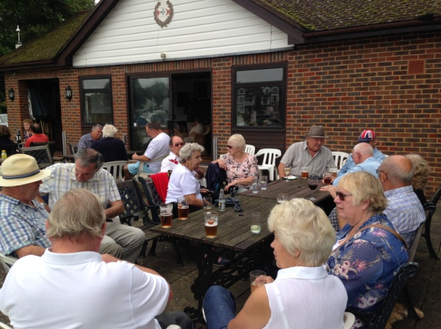
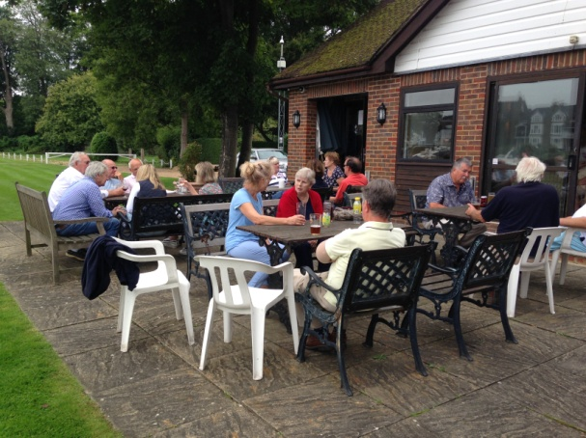

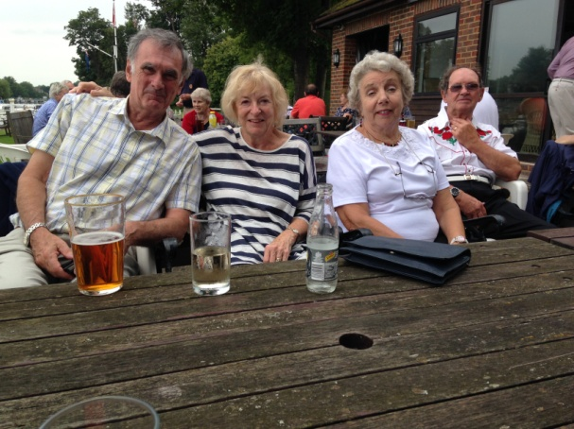
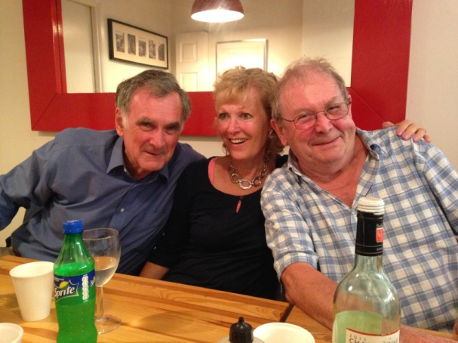

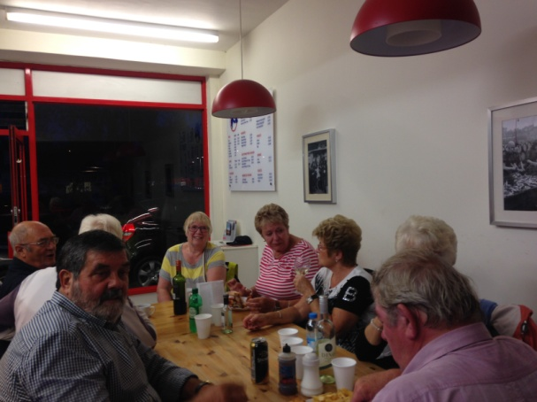
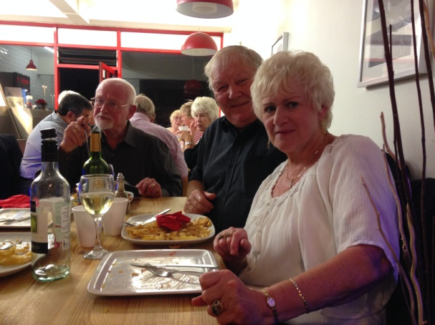

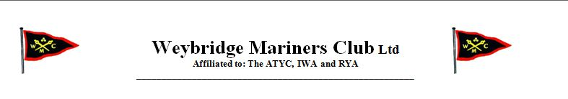

MEDIA RELEASE
08/09/15
The Weybridge Mariners Club Hosts War Veterans
Aboard The Dunkirk Little Ships.
On Sunday 6th September 2015, 19 preserved vessels of the Association of Dunkirk Little Ships (ADLS) sailed up the River Thames from Hampton Court where they had assembled at the Thames Motor Yacht Club, and
on to the Weybridge Mariners Clubhouse at Shepperton Lock Island.
Aboard each of the Little Ships were veterans of World War 2, including
9 remaining veterans of the Dunkirk Evacuations, members of Bomber Command, The Atlantic and Russian Convoys, POWs, the Normandy Landings and a number of Chelsea Pensioners: the oldest among the guests was 98.
Also welcomed were the Mayors of Spelthorne and Elmbridge and Captain Andy Jordan RN, Commander of the Naval Training School Collingwood and a number of his young Able Seamen.
On arrival at Shepperton Lock Island the veterans were disembarked at the Weybridge Mariners Club Moorings to the accompaniment of a Highland Piper. Here the Club Members provided lunch for over 120 veterans and their helpers and also provided entertainment. Many of the Veterans departed in vintage cars, assembled on the Weybridge bankside.
END

THE DUNKIRK VETERANS DAY AT THE WMC
Sunday 6th September 2015
Back in July Lesley, Rob and I met Ian Gilbert (ASDL Commodore) and his team to start planning the annual visit of the Dunkirk Little Ships and World War 2 veterans. There was a lot to organise: Environment Agency (EA) off-side moorings and off-side car park to reserve, EA pontoon to book, and the piper and entertainment to book. Finally, there was the Club organisation to plan.
Friday before the event all was made ready: clubhouse polished and bunting hoisted, tables set out and laid, pontoons cleared of moored boats, marquee erected on the sundeck for the Naval Ratings – for which we were thanked by Captain Andy Jordon RN for allowing the Ratings to be part of the celebration (must do the same again next year). Much of this was achieved by marvellous support from the Friday mob. The Club was ready to welcome the Dunkirk Little Ships, veterans and helpers, VIPs and Naval Ratings. The clubhouse looked incredible.
Lesley had selected a menu of stew and dumplings followed by treacle tart and custard and had recruited a catering team of 11 ladies, each cooking a set portion of the food required to dine the expected 120-plus guests and feed the club members. A mammoth task, which thanks to the catering team’s excellent cooking, resulted in a mouth-watering dinner; with many compliments from the guests.
Sunday, and we were eager for first sighting of Dunkirk Little Ships. Club members were in their allocated positions ready to receive the veterans as they disembarked: each member with a particular job to do - and what a professional job everyone made of it (at times, the competition between two of the mooring teams was hilarious). It made you proud to be a WMC member. Someone must have said their prayers because the weather could not have been better.
Mandy took the lead in managing the “Meet & Greet” team, with members at each pontoon to help with disembarkation and upstairs to welcome and seat veterans and their helpers. Members were allocated to mooring master, pontoon mooring teams, ferrying and far bankside control. Bev provided Kool Kat and Molly May as ferries. Everyone dealt very ably with their allotted tasks with no further input required from me. Terry Hoyle was our photographer for the day (and his photos and Mike’s video can be viewed on the clubhouse screen).
At 12.30 the first batch of Dunkirk Little Ships rounded Doyley Carte Island, nineteen having cruised up from Thames Motor Yacht Club at Hampton Court. As each boat navigated into Shepperton weir pool the Club’s mooring master directed them onto their allocated pontoon. When the boats had been made fast by the Club mooring crews, Naval Ratings on board each boat helped less able Veterans to disembark. As club tradition has it, a lone piper (Ron Brown) played as the Veterans disembarked.
Aboard the boats were veterans from WW2: Dunkirk, Normandy, Arctic and Russian Convoys, POWs and Bomber Command; also included were Chelsea Pensioners. I have since learned the oldest vet was 98 and two veterans met for the first time in 72 years. Guests of Honour were Captain Andy Jordon RN, Officer Commanding HMS Collingwood, the Mayors of Elmbridge and Spelthorne and the Commodore of the ADLS, Ian Gilbert.
Once it began, the flotilla of Little Ships came fast and furious, all in excellent condition and looking as good as new; proudly flying their colours: the St George’s Cross defaced with the Dunkirk coat of arms. It was interesting to see the large number of gongoozelers (spectators) on the Weybridge bank, viewing the spectacle of boats as they manoeuvred into position. A great advert for the club. Our off-side mooring team (ok, Les, Tom, Bob and Brian) did a handsome job of ensuring that all the Little Ships moored safely along the river bank and kept up a constant ferry service.
Once off the pontoons, guests were welcomed by WMC Meeters & Greeters and escorted into the clubhouse to their seats. It was a difficult job getting everyone to sit down when most wanted to chat with old comrades. Eventually order was achieved and while the dinner was being served Sophie entertained with nostalgic WW2 songs. A Pearly Queen was also there to chat with the guests (and asked to come again next year). I noticed that some of our lady members were flirting with the Vets (the hussies); it all made for a very happy gathering, and praise from the guests for the warm welcome they received. It was so busy that at times the bar seemed to be overwhelmed, but thanks to the bar “staff” (Jackie and Maggie) and additional volunteers behind the bar, the long queue was quickly dealt with.
With dinner concluded it was time for guests to depart with many fond farewells. Mind you, it took some while for the guests to stop chatting and depart. Who knows, some may not return another year. Eventually, peace prevailed and an exhausted WMC crew could relax, eat and reflect on another successful Annual Veterans Day. What a team of members we had. All played parts they were given with professionalism. In no way could it have run so smoothly without everyone’s cooperation; my personal thanks and that of VC Lesley to all who took part – too many to name individually. It was pleasing to see that over the following week there was press coverage of the event in the Surrey Advertiser
So, when do we start planning it all over again? Help!!
Jim Pothecary

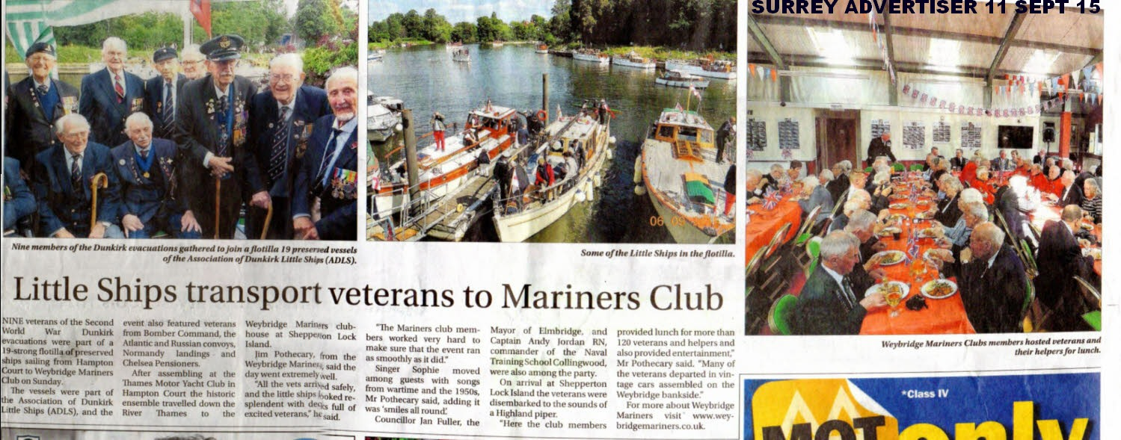
News article, featured in Surrey Advertiser on 11th September 2015

Commodores Sailpast
Sunday 20th September
The annual Commodore’s Sail Past was held on Sunday 20th September. The day was perfect, the weather was hot and sunny, with plenty of activity on the river. With the folding doors onto the balcony open wide, the clubhouse looked as resplendent, as usual. It promised to be a great day out for the members in the Sail past and those visiting to support the Commodore (moral not physical!!).
The sail past was attended by 14 boats of all shapes and sizes. The gathering of the boats started at Lady Lindsey’s Lawn in Shepperton, where the craft assembled from 10.00am onwards. The procession left there at around 11.00am and proceeded up river towards Shepperton lock for the sail past at the Mariners Club at 11.20am. Ensigns were lowered while sailing past the Clubhouse as Jim Pothecary, the Commodore took the salute from the balcony.
The lunch afterwards was a ploughmans, all sourced by Ann and helped in preparation by Heather, Annette & Doreen. Once everyone had gathered, the bar did good business and was open all afternoon; admirably manned at the last minute by Mike. All in all it was a very well attended day by members and guests.
This annual event is always popular, overlooking the river from the balcony and making an impressive view from the Weybridge bank. The previous week’s major attraction had been the Dunkirk Veterans Lunch, which I thought was exceptionally good this year; so the Sail Past was a perfect follow-on from that.
The club is always popular and has had a good summer, which isn’t over yet and the clubhouse must be one of the hidden gems on the Thames. We can all look forward to more gatherings, afternoon, evenings and weekend events for the rest of 2015, which are all in the 2015/2016 Programme.
David Perry.

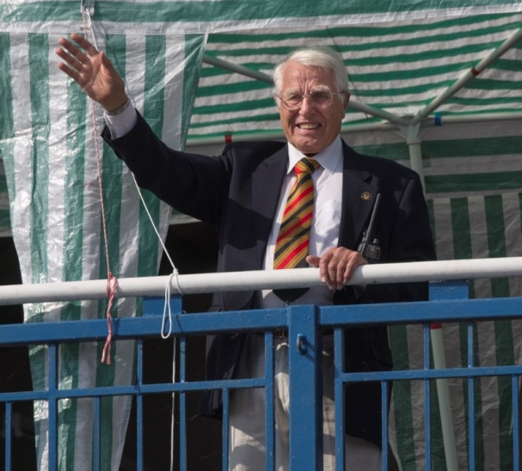
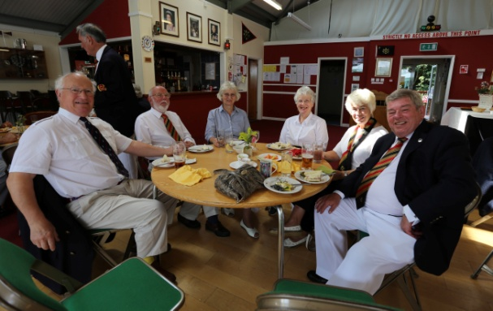
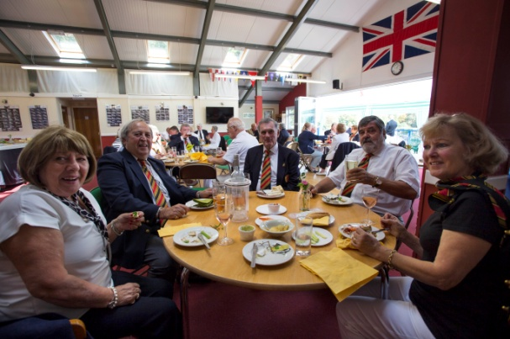
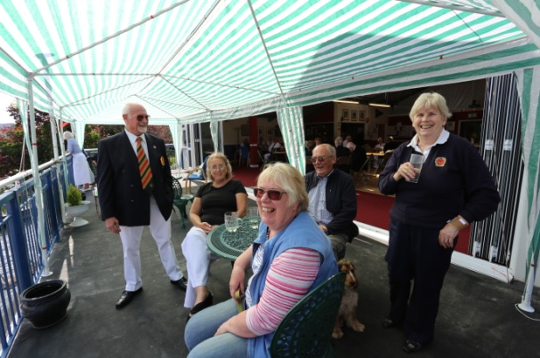


In Memory of Simon ...
Wendy’s son Simon lost his brave fight and passed away in the early hours of 12th September, following multiple organ failure. He had been admitted to hospital with a very severe chest infection with very serious complications. Simon’s sense of humour and social nature touched many members at the club.
Wendy wishes to thank all those who, so kind and thoughtful, sent their good wishes, cards, texts and phone calls.
We send Wendy our sincere condolences and to know that we are thinking of her at this very difficult time


Dates for your diary ...

October
Saturday 3rd October Ladies Night **CANCELLED**
Saturday 17th October Laying Up Supper
Saturday 31st October Casino Night
November
Saturday 7th November Weekend Away
Saturday 21st November 70s/80s Night


Reminder: WMC Dinner and Dance
This is a reminder about the WMC dinner dance, which is taking place on 7th November. Names, and food are required to be put on the club noticeboard, or notified to lesley.hamments and payment by Friday 23rd October at the very latest.

Joke Corner ...


and finally...
Following on from the recent coverage in the last newsletter (August 2015), concerning the recent accidents that have occurred on the Thames with petrol boats. The Environment Agency has issued the following guidelines:
You may already have heard that over the past few weeks, several serious incidents linked to the use of petrol on boats have seen 9 people needing hospital treatment, 2 other people injured and 8 boats damaged or destroyed.
We are contacting owners of boats with petrol engines directly with important advice that will help keep you, your crew and your boat safe.
You have a shared responsibility with us to prevent injury and damage from the use of petrol, so please read and follow the 10 petrol safety essentials below.
More information is available on the website:
http://www.boatsafetyscheme.org/stay-safe/petrol-safety/
Ten Essential Petrol Safety Tips for Boats
All boaters using petrol, and especially anyone new to boating, should appreciate the nature of petrol vapour especially in the context of the bucket-like quality of a boat cabin and hull.
The fundamentals are that petrol, when spilt or exposed to open air, can vaporise quickly and the vapour can be ignited easily by any spark, flame, cigarette, etc.
Even a small spill of petrol will create a large amount of vapour. Likewise when it is being poured and when a tank is being filled, the vapour in the ‘empty’ tank is displaced by the new liquid fuel.
Escaping vapour will sink to the lowest level of its surroundings, accumulating at low level in places such as cabin floors, lockers, bilges and other ‘still-air’ spaces.
Even if the concentration of vapour is too rich to ignite immediately, it will dilute creating the potential for a serious fire and/or an explosion, even though, given enough ventilation, it may dissipate to a safe level eventually.
These are ten petrol safety essentials that will help keep you and your crew safe:-
- Before starting out, use all senses to check the fuel system and engine for petrol leaks or any signs of damage or deterioration. Have any problems sorted out first.
- Do not switch on the electrical supply or turn the ignition key if there’s a strong smell of petrol. Stop immediately if there’s a strong smell of petrol after you start.
- Keep vapour out of the boat! Before refuelling, close all windows, hatches, doors and awnings; also turn off all cooking appliances and any other ignition sources
- Double check before you start pouring, that you are using the correct filling point.
- Afterwards, clean up any spills straight away. Be sure to re-secure the filler cap.
- Avoid decanting petrol from containers, but if you have to, use anti-spill containers, spouts or nozzles to allow, clean and easy, no-spill refuelling.
- Don’t carry spare fuel, unless it is needed and then it must be in cans specifically designed for petrol. Always keep within the legal capacity limits.
- Containers should never be filled completely and must be stowed securely upright, away from intense heat and out of direct sunlight to prevent pressurisation.
- Refuel any portable engine or tank ashore and safely away from any sources of ignition. Always follow marina / mooring rules on petrol refuelling and handling.
Never use any bowl, bucket or other open container to carry or transfer petrol or mix in 2-stroke oil.

Copyright © 2015 Weybridge Mariners Club Limited, All rights reserved.
Our mailing address is:
News_at_WMC@outlook.com

