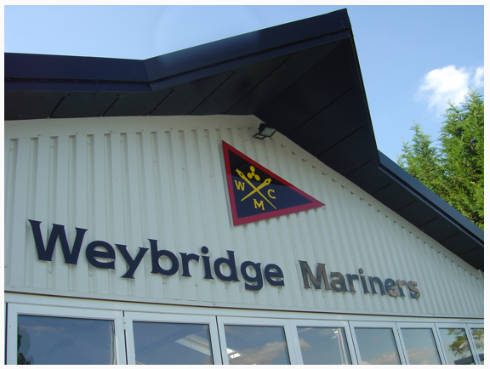

December 2017 Newsletter

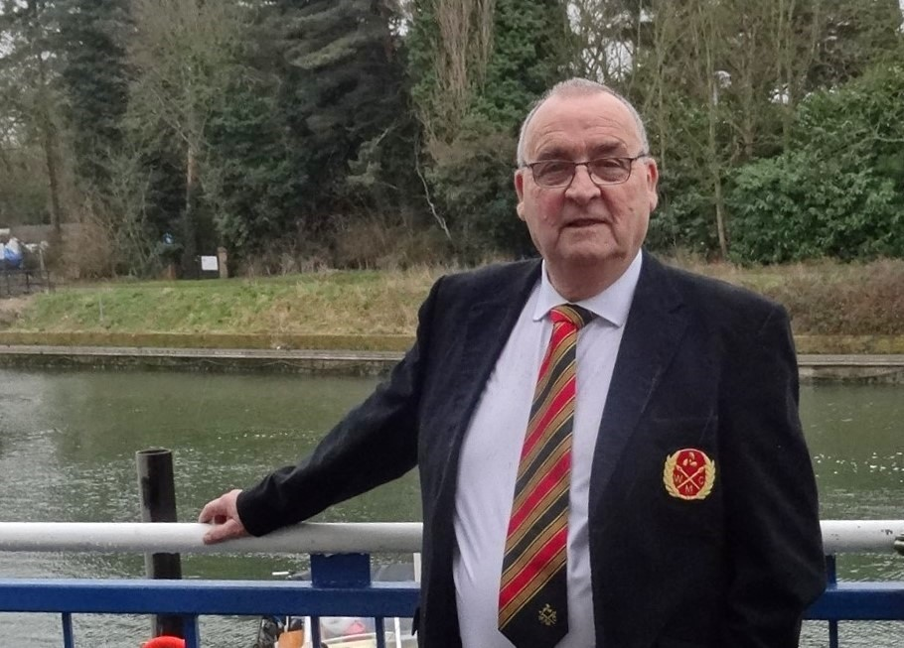

Commodore's Report
Dear Members
We are coming to the end of another year and all is well with the club. We had a great time at the Christmas party and the social team gave us a fantastic meal with all the trimmings. Also thanks to the members who helped decorate the club. We were let down by the entertainer but Mike and Chris stepped in and arranged the music, well done to both of you. We had a free raffle with some very nice prizes and we danced till late.
Well the next get together will be the A.G.M so I will see you all then. Happy Sailing.

Roy Nash
Commodore
December 2017


Dates for your diary ...

January
Sunday 14th AGM
Further details regarding future events and the 2018 cruise plan for the club will follow when available.

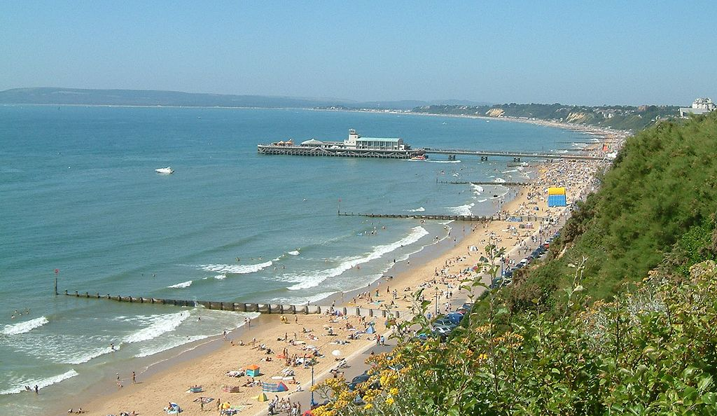
WMC Club Annual Dinner Dance Weekend away
17th - 19th November 2017

We stayed at the Cumberland Hotel on East Cliff in Bournemouth. The Hotel is lovely and the staff are very good, also the food, overall very good service.
Including guests there were 53 in attendance. The weekend began on Friday lunch time when some of the members met at the Ship Pub in Lymington for lunch which was most enjoyable, it was then on to the hotel to check in. All members and guests had sea view rooms which was a bonus.
Friday evening we all met for pre-dinner drinks then sat down for dinner, good meal and convivial atmosphere.
Saturday morning very good buffet breakfast after which we all went our different ways, shopping in Bournemouth, driving out to Poole etc. The weather was kind to us, dry and bright.
Saturday evening after a gala dinner we were entertained by a 5-piece band organised by the hotel manager which kept is on our toes, much dancing and a wine or two !!! Usual raffle and a very successful evening.
Sunday, Breakfast after which we all made our way home.
Heather and Frank

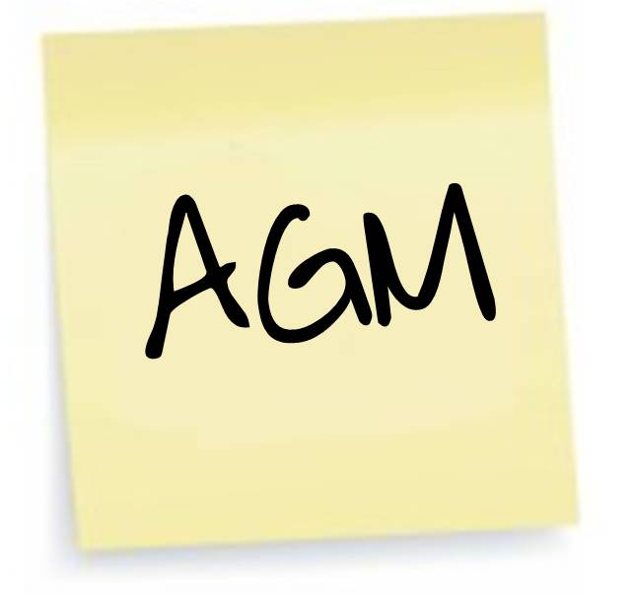
WMC AGM
A reminder that the clubs 57th AGM is to be held on Sunday 14th January 2018, details regarding members standing down from committee positions and advising
of those members offering to serve the club again in 2018 were provided in the November newsletter.


18th - 20th May 2018
As you probably know, one of the Honorary Secretary's tasks each year is compiling and arranging the publication of the Club's programme and diary for the coming year, and as part of organising the AGM to facilitate the election of Officers and Committee members for the coming year. I can advise members that, at the present time, we do not have a member who is prepared to volunteer for the position of "non-tidal Rear Commodore".
If that situation continues beyond our forthcoming AGM, and in the absence of a 2018 "Rear Commodore (NT)" I would like to suggest that individual members might feel that they could volunteer to organise just one non-tidal event. As a starter I would like to volunteer to try and organise a club cruise to Windsor for the Royal Wedding Weekend, Friday 18th - Sunday 20th May 2018.
I would be very interested to hear any thoughts or comments that any member has on the above.
Best regards
Rob Fry
Honorary Secretary


Dear Members
I am advised by our very own "Mr Fix everything" Jim Hamments that the club has purchased three extension table tops, to enable us to comfortably seat more than six people at a round table for club and private functions. One of the new table tops has been set up on a table in the clubhouse for members to view. The new table tops are hinged through the centre for easy storage and must always be set up with the centre hinge upwards to enable the table top to be easily folded for dismantling and for storage. The underside of each extension table top is fitted with nonslip pads for safety and to prevent damage to the six-seat table top that the extended table top is set upon. So please don't be put off from inviting a party of up to 9 members and guests as we can seat you all on one round table, and for those members who would like to bring a party of more than 9 we always have the facility to set up long tables for whatever size of party you want to bring to any event!
Best regards
Rob Fry
Honorary Secretary


ATYC Update
Dear Members
On behalf of Chris Knight, the WMC representative to the ATYC, please find attached the latest ATYC Newsletter.
https://gallery.mailchimp.com/c74d5d0274077f9767e590674/files/31f093d0-88d2-45ac-9c1b-fac7f09b09d2/ATYC_NEWSLETTERDec17.docx
Kind Regards
Rob Fry
Honorary Secretary


Pat Kelly
it is my sad duty to advise members that Pat Kelly, a very long serving past member of the club, passed away on the 27th December 2017. Pat will be remembered by many members, not least for her energy and enthusiasm on the dance floor, and as the wife of Past Commodore, the late Jim Kelly. Pat had been gravely ill with lung cancer for quite some time.
I am sure that you will all wish to join me in expressing our sincere condolences to Pat's two sons; Ian and Darren, and her wider family.
Pat's funeral will take place on Friday 19th January 2018, at 11.40am at Kingston Crematorium, Bonner Hill Road, Kingston upon Thames, KT1 3EZ.
Details of the Kelly family's preferences regarding floral tributes, charitable donations and the funeral reception will follow as soon as I have that information.
Best Regards
Rob Fry
Honorary Secretary


- Lesley and Ann have taken over responsibility for housekeeping. If you find a shortage of any consumables (loo rolls, towels, soap, detergent etc) then please let them know.
- In line with the shops having their January sales in December, our spring cleaning has been brought forward - the cloakroom has been decluttered, please can we ask you to keep it that way.
- The rotting steps to the front door will be removed shortly and replaced with new steel ones. The first stage will be to prepare suitable concrete foundations, so there will be a period when the only access will be via a step ladder to the entrance platform or through the riverside doors. Hopefully this will not be too much of a hardship to you Mariners, used to hopping on and off boats!

Copyright © 2016 Weybridge Mariners Club Limited, All rights reserved.
Our mailing address is:
News_at_WMC@outlook.com

