WMC 2 WEEK RIVER CRUISE FROM 6th JULY – 20TH JULY

The 2 week up-river cruise started at Windsor on Saturday 6th July2013. 14 boats took part. They were China Rose, Alouette, Bibi, Rude Knott 2, Enterprise V, Weather or Knot, Lady Farrington, Gorgess, Nkwazi, Saxon Princess & Festivity. Mustard, Kitty Bee and Gowie joined us at some locations.

It wasn't a conventional cruise where everybody started together. Boats were joining up at various stages due to other commitments. China Rose and Enterprise V were first to arrive on the Saturday at Windsor followed by Nkwazi and Saxon Princess. We all had drinks and nibbles on Enterprise V and sat outside till late as weather was marvellous which continued the whole of the first week and forecast for the 2nd week was good too. We stayed Sunday also at Windsor and some watched the Wimbledon men's final with green tea and strawberries! Mustard joined us on Sunday. In the evening some of us went for a Chinese meal and others decided on an Indian takeaway.

On Monday morning we all went on to Cookham where we stayed 2 days. We had a BBQ the first night and were joined by Festivity. We had some excitement as during the BBQ a tree started to fall down quite dangerously and Gill's niece who was crewing for her is a policewoman quickly got it sorted by ringing the police and tree surgeons who sealed off the site to the public and cut the branches off. Next morning at 8am more tree surgeons came and finished the job, all very impressive. Gorgess arrived late afternoon on the Tuesday. On Wed. Festivity set off followed by Saxon Princess for Henley as they had moorings booked. The rest of us set off to see where we could find moorings as it was very busy on the river. Some moored at Marlow. Gorgess went on and China Rose and Enterprise V moored by a meadow near Maple Durham complete with noisy sheep!

Thursday we managed to moor at Henley town. We were joined by Bibi and Alouette. We decided to stay Friday too and were joined by Weather or Knot, Lady Farrington and Rude Knott 2. Mike and Ann kindly offered to take us on their boat to see and hear the music and fireworks, Madness were on and it was wonderful to hear them and feel part of the Festival. A truly great evening thanks to Mike and Ann who took 11 of us on board.

On Saturday we went to Sonning to the Upper Thames Yacht Club where Roy had booked the moorings. Wendy co-ordinated with UTYC and they managed to get all 8 boats in. It was a lovely place and they made us very welcome. In the evening we all went to the Mill for dinner and theatre.
We were joined by Kitty Bee and Nkwazi,.Roy and Gill came up by car.

On the Sunday Gorgess, Kitty Bee, Nkwazi, Mustard and Enterprise V started on the homeward journey. Saxon Princess and Festivity remained at Henley and the other boats continued up-river to begin their 2nd week of cruising. We thoroughly enjoyed our time on the river and the company of everyone and a special thanks to John and Wendy for all their help.

Sally Holdaway.

-------------------------------------------------------------------------------------------------------------
Second week of Up-river Cruise

After a lovely evening at the Sonning Theatre, the remaining boats left the following morning to go further up-river. All sadly but Lady Farrington who has broken down a little before Sonning and had limped in to the UTYC where it stayed until Wednesday with Mandy and Terry having to be taken home. Terry and Mandy came back Wednesday and replaced the gear box and I am told that Mandy went under the boat to free the prop of rope wrapped round it. How brave is that! Little did I know at the time that we would experience similar problems!!

Nkwazi and Mustard went on to Pangbourne as it is a lovely place for the dogs to run freely and the remaining 5 boats, China Rose, Weather or Knott, Alouette, Rude Knott 2 and Bibi moored outside Beale Park. The following day Ann and I could not resist going there to see all the wild-life as neither of us could remember how long it had been since we last went. Rude Knott 2 travelled on to Wallingford and Bibi to Shillingford whilst our men did boaty things (or so they told us!)

We both travelled on to Wallingford the next day and were very surprised to see how it had changed since our last visit so long ago. It had beautiful new moorings either side and lots of them too. It also had a Splash Pool and Swimming Pool right by the riverside. Idealic for children. The following day some of us made our way to Abingdon which was still as lovely as I had remembered. So long since I had been. We sought out the lovely Italian restaurant that we had eaten at many years ago with Jackie and Pete. I was amazed John could remember where it was. When we arrived back to the boat we were pleasantly surprised to see Gowie who had been all the way to Lechlade.

The following morning we were at last on the homeward stretch, we passed Rude Knott and Bibi who were moored in Henley and then Saxon Princess and Festivity further downstream. 4 of us moored at Goring and had a very pleasant BBQ until I managed to drop the boat keys in the river when trying to over laden myself with carrying everything back to the boat. All the keys were on a floater but they were nowhere to be seen! All the men had their magnets out scraping the river bed but no luck. I felt so bad for causing so many problems. We were all just about to give up and Chris Knight was talking about hot-wiring the engine when Jim from Gowie shouted that he could see a set of keys floating past his boat! I have never seen the boat hooks out so quickly. Thank you Mike for fishing them out before they floated too far away. They had apparently floated under 4 boats and popped out at the end of Gowie.

From Goring we all pretty much did our own thing and as we needed to be back by Saturday, booked Hurley Lock mooring which Sally had recommended to us and we loved the mooring and the quaint old village next to the moorings.
The following day we made a really early start (7am) and I worked the locks whilst John did the rest. We got to Cookham Lock at around 8am and I had opened the lock when a huge gust of wind took the end of John's rope and it wrapped itself firmly round the prop! We weren't going anywhere!
After much discussion, John donned his swimming trunks and dived down to try to free it. After 4 dives he was not able to free it as the water was too murky for him to see what he was doing and he was going by touch. He told me to go and get his knife to try to cut it free. Luckily, he did not need it as on the 5th attempt he managed to free it and lots more rope that the prop had managed to pick up. Well done John. Thank goodness the weather was so warm. So much for the early start!

The rest of the trip I am pleased to say was uneventful and we arrived home in one piece.
What a lovely 2 weeks we had and of course the weather was exceptional. I am sure everybody felt the same way. Thank you all for such good company and thanks Roy for booking the theatre for us.

Wendy McPhee.
----------------------------------------------------------------------------------------------------------------------
From Roy:

I left my moorings at Penton Hook on the afternoon of July 6 and travelled to Windsor alone to meet up with John and Wendy on China Rose, David and Denise on Nkwazi and Les and Sally on Enterprise V. When I arrived they all assisted with my ropes and had a cold beer waiting. Later in the evening Charles and Janice joined us. For dinner we ordered an Indian take away. Poor David never got what he ordered but helped us with ours.

From Windsor we moved on to Cookham and hoisted the club flag and got settled for the night. Later on Monday Gill arrived on Festivity with her Niece Anita as crew and just in time for our barbeque with David as cook. We were all relaxing and suddenly a very loud cracking sound was heard and a large bough of a tree next to us came crashing down. Fortunately we had Gill’s niece Anita with us and she is a police woman and soon got on the case. Anita called the police and arranged for the area to be cordoned off with police tape. From then on she got out her warrant card and directed the public away from danger. Well done Anita.
On Tuesday morning Gill and I left them behind and with both of our boats we headed for the music festival at Henley.

When we arrived at Henley Gill moored bank side and met up with her friends from the Star craft club. I arrived about one hour later and rafted alongside Gill. After a large glass of Pimms Gill and I took my boat to moor up on the booms in the middle of the channel. When we arrived at our mooring point we were greeted by Harvey and Joy and they assisted us with our ropes. They have now joined the Mariners club.
As we were moored mid stream we had to lower my dinghy to return to the bank side. I fitted on the out board motor and we climbed aboard and off we went. (See photo taken by Joy).
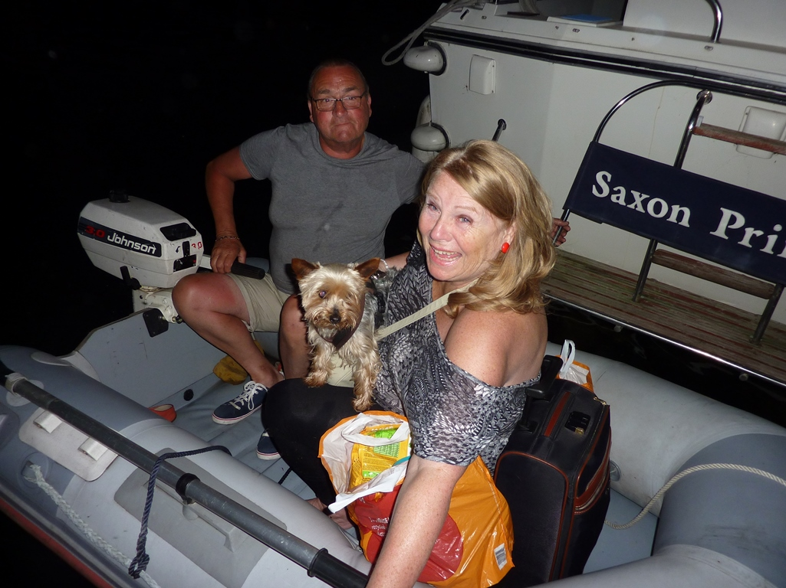
As we were going toward the bank Gill said “My feet are getting wet” Oh dear I did not realise the dinghy leaked, but we made it, Phew. Later that night we had to return back to my boat not worrying about the leak as we were well oiled by then. I bailed out the dinghy and with the 2 dogs on board and no navigation lights we set off to my boat. Now we were a little concerned as it was not only our feet getting wet and Gill was shouting out May Day, May Day, we were not only sinking but all the boats moored up looked the same in the dark. Eventually, wet and embarrassed we found my boat.
On Wednesday we went into Henley with friends for lunch. After lunch we went shopping for a new dinghy. Three hours later we returned and launched her. That evening we were to go to the main arena at the music festival as we had tickets to see The Beach Boys in concert and it was a fabulous show. After the concert we returned to watch the firework display. On Friday we were joined by Gill’s family and we cruised up and down the river dancing to the music of Madness.
On Saturday we took part in the Star craft Olympics and we all had a fun time. On the Saturday evening we met up with the other 20 members of Weybridge Mariners and went to Mill at Sonning for dinner and a show. We had a fun time but some members left us in the interval and went back to their boats. We planned to leave Henley on Sunday and catch up with other members of the club but got delayed and decided to leave early Monday morning. On Monday Gill had a call and had to go home for a few hours. I had a call from Martin Powell of Penton Hook Yacht Club and we were invited out to dinner with Martin and Denise and other members of their club and had a lovely evening and decided to depart on Tuesday morning.
We left Henley on Tuesday and headed up river planning our first stop to be at U.T.M.Y.C. at Sonning to check up on Terry and Mandy on their boat Lady Farrington as he was changing a burnt out gear box caused by a rope being tangled around his prop. As we waited outside Sonning Lock we heard a squeaky voice calling my name, I looked over the stern and there was Denise Norfy in a canoe shouting, “You just passed David and me” We turned around and went back to join them for lunch. We were so relaxed we decided to stay the night and go out for dinner with them.
The next morning we left and went to meet Terry, when we arrived he had fitted the new gear box; we made him tea and went on our way. We stopped at Reading for food as Tesco but it was very busy and we had to moor up in the bushes about 4 feet from the bank. I tied the stern to a tree and spliced a tightrope for Gill to walk on to get on the bank and then we set off to Caversham for the night.
On Thursday morning we got up early and were getting ready to carry on up stream and I got a call from David to say he had left his wallet in the pub at Sonning, so we turned back to collect it as he was already back at Cookham on the way home. After collecting the wallet we decided to cut our losses and return to Henley. On Friday we were joined by Wendy and John and Cris Knight, they invited us aboard for a drink and then they set off home with David’s wallet on board. Later on Friday, Terry, Mandy and their new gear box joined us. Terry told us that Mandy put on her swimming costume goggles and snorkel and jumped overboard to cut the rope from the prop (I bet that cost him more than the gearbox).

Saturday and Sunday we attended the Thames Traditional Boat Rally at Fawley Meadows.
It was a great weekend with all the traditional wooden boats, Vintage cars, Motor cycles and Bicycles. There were lots of stalls with boat bits and people selling clothes and bric a brac. The boats cruised by and there was a running commentary giving us all the information on the different craft. On the Saturday evening we danced the night away in the marquee to a great Rock and Roll band.
We had planned to leave for home on Monday morning but unfortunately Alfie (Gill’s dog) had an accident and could not walk so we decided to make way and left Henley at 14-30 on Sunday.
We got as far as Boulters lock by 19-00 and from then on we had to work the locks ourselves and arrived at Penton Hook just after midnight. The worst part of the journey was when we got to Bell Weir; Alfie jumped out of the widow, onto the deck and joined Gill on the bow of the boat without any sign of a limp. Gill would not let me near him, I wonder why!!

Roy Nash – Rear Commodore.



